2018

Bowie State University

12/5/2018

**Emergency Alert and assessment for training purposes**

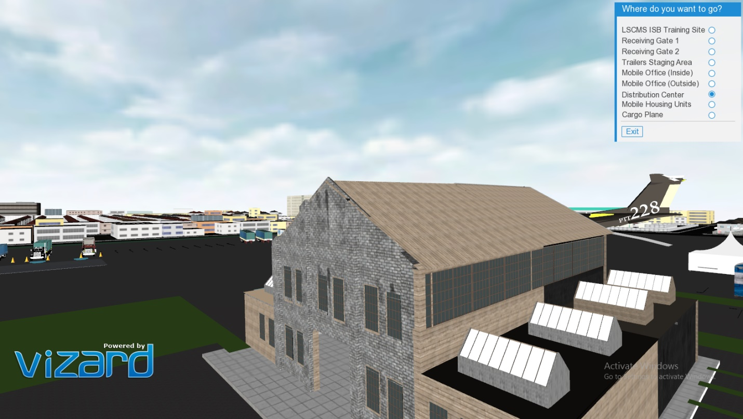

Chaoui, Nada

Rosario, Reynaldo

COSC 590 - [Virtual Reality and its Principles](http://cs.bowiestate.edu/sharad/vrml/index.htm)

Dr. Sharad Sharma

**Emergency Alert and assessment for training purposes**

**Introduction**

FEMA (Federal Emergency Management Agency) is an agency that supports the citizens and first responders. It coordinates the federal government's role in preparing for, preventing, mitigating the effects of, responding to, and recovering from all domestic disasters, whether natural or man-made, including acts of terror. In the century that followed, ad hoc legislation was passed more than 100 times in response to hurricanes, earthquakes, floods and other natural disasters.

As FEMA’s warehouse facility is far from their assistance offices, they have been struggling when training their employees. We are proposing to provide them with a virtual environment to train their new hires before they go on site.

What a better way to train the employees and have a closer look to how everything happens other than developing a virtual and augmented reality application? This project is developed for the purpose of simulating an emergency situation along with taking assessment to provide training to FEMA’s employees. This application will be beneficial to the organization and its employees.

**Goal and objective**

Our project is to provide a virtual environment that corresponds to FEMA’s requirements and needs to train their employees virtually. As their Facilities are nationwide, the use of a virtual environment will help them train their employees before they go on site which will save them time and money.

The employees training project is based on the logistics that FEMA goes through at an emergency alert of a disaster. This project consists of two parts; the simulation of an emergency alert and assessments for training purposes.

At the simulation of an emergency alert, the screen color changes to sepia and fire appears at one of the buildings in the environment and an emergency alert sound starts. Then, the receiving truck arrives, parking inversely, simulating a sound when backing up. The user will have to load the truck with the pallets/skids in the warehouse and ship it to the emergency area.

The assessment training consists of testing the user if he knows what each truck is supposed to do. At the trailers staging area, the user will be able to navigate around the warehouse after answering the questions correctly. While, at the receiving gate, the user will have a form to fill out which will automatically appear at the mobile office.

**Modeling**

Using Sktechup and Vizard art tool, we have successfully been able to create an environment of a distribution center that consists of a warehouse building, parking space, grass, sky, light, people, trucks, trailers, mobile office, computers, equipment, tents, cargo plane, portable restrooms, houses, ramps, yellow cones, etc. Even though our main focus is the simulation of the emergency alert and training at the distribution center, we have added a town surrounding the center to make the interacting space more realistic. We also have keyboard callbacks that simulates certain scenarios. Our user, the trainee, will have to follow the instructions in the info panel to complete each task. As the user/employee runs the application, he will have a pop up screen that provides him with the information needed to know to how to navigate.

On the top right side, there is a panel that redirects the trainee to different viewpoints; Top main view, receiving gate1, receiving gate 2, trailers staging area, mobile office(inside), mobile office(Outside), distribution center, mobile housing units, cargo plane. The user will have the choice to either navigate around the center using a mouse or click on the viewpoint panel to save time.

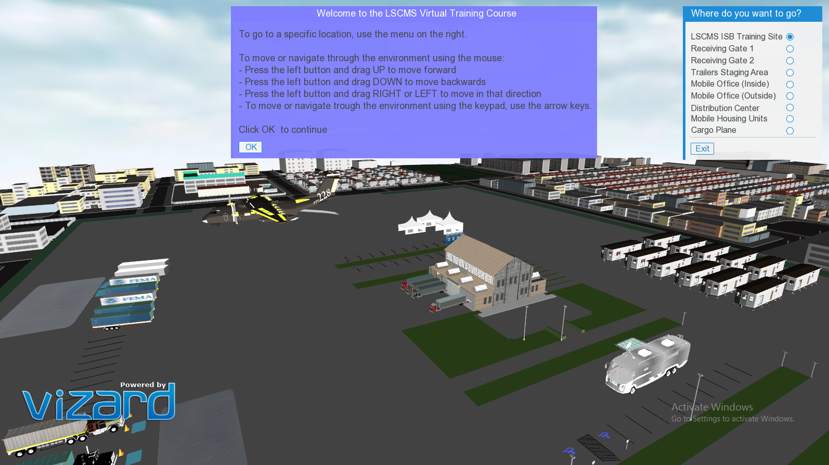

Bird view of our environment

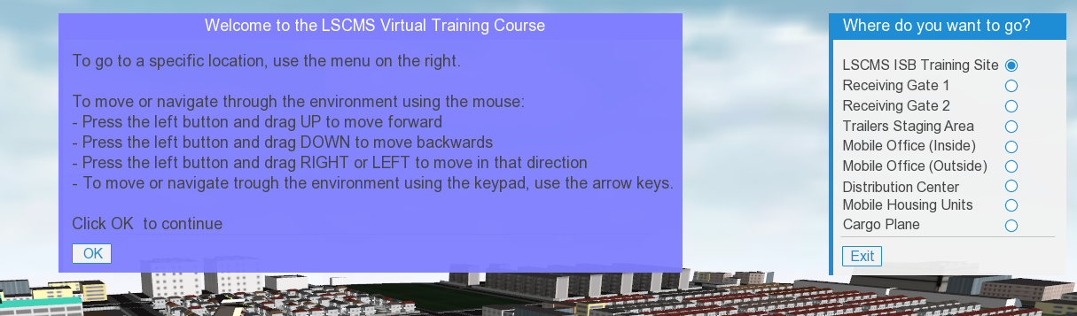

directory panel while running the application

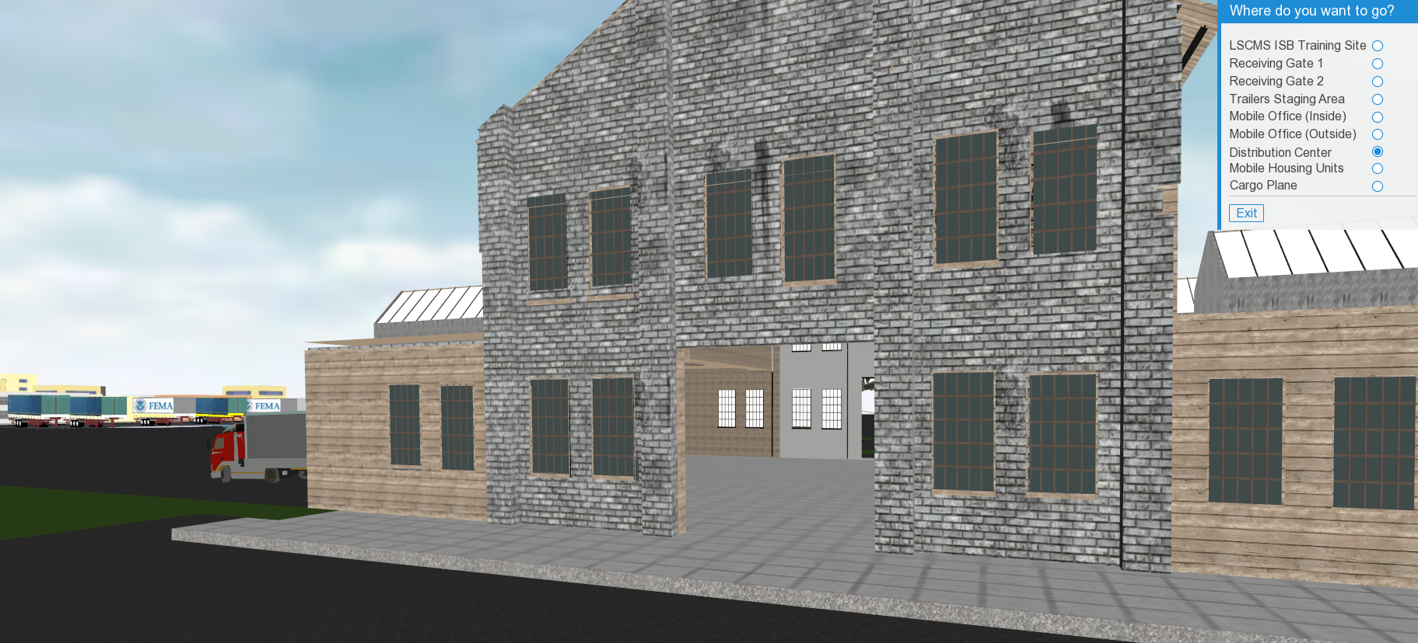

The front of the warehouse

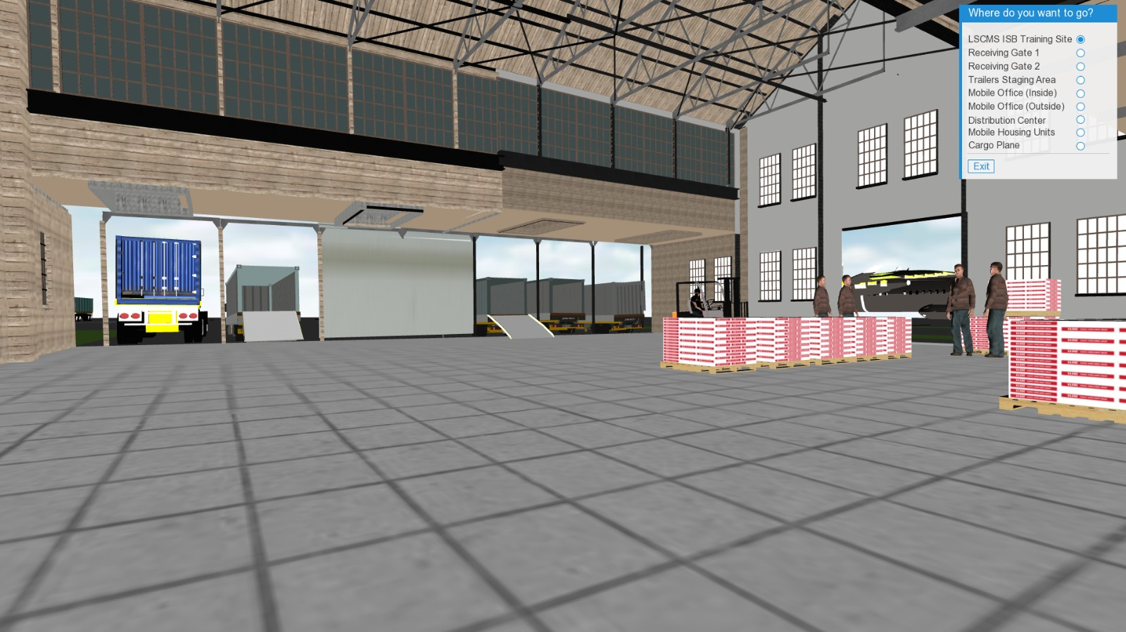

The inside of the warehouse

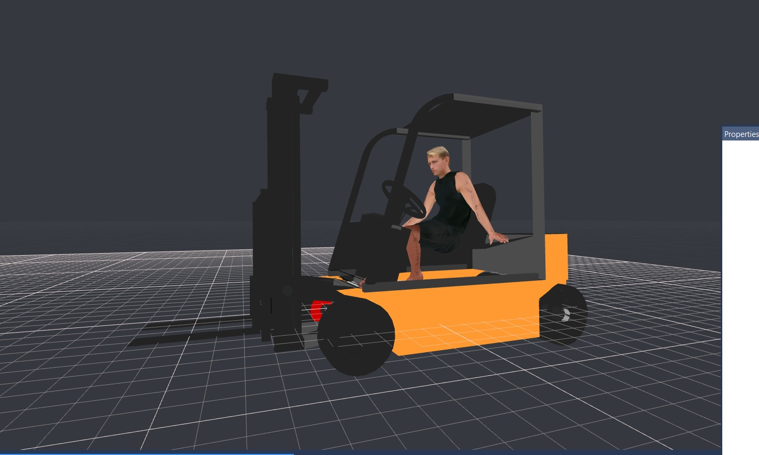

Fork lift used inside the Warehouse

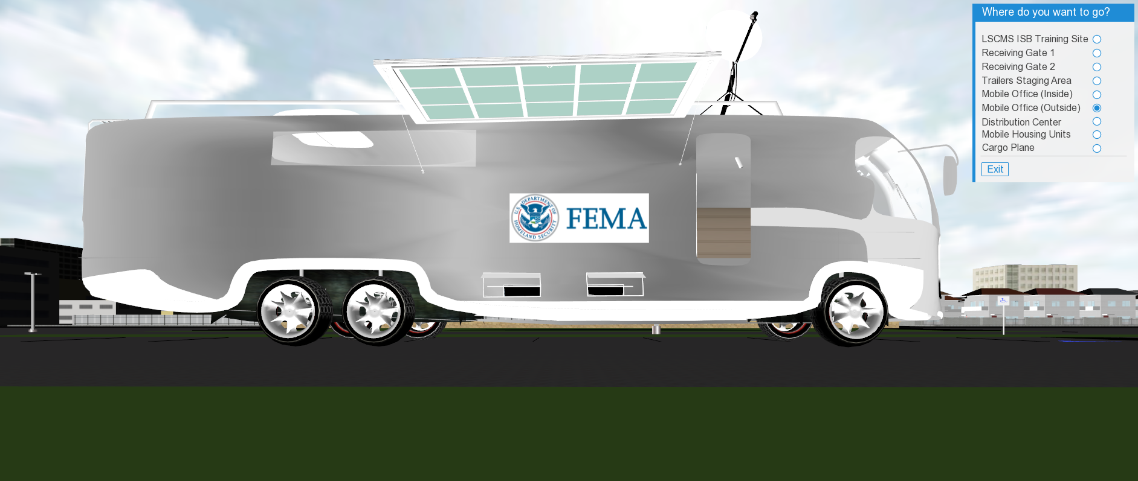

Mobile Office - outside

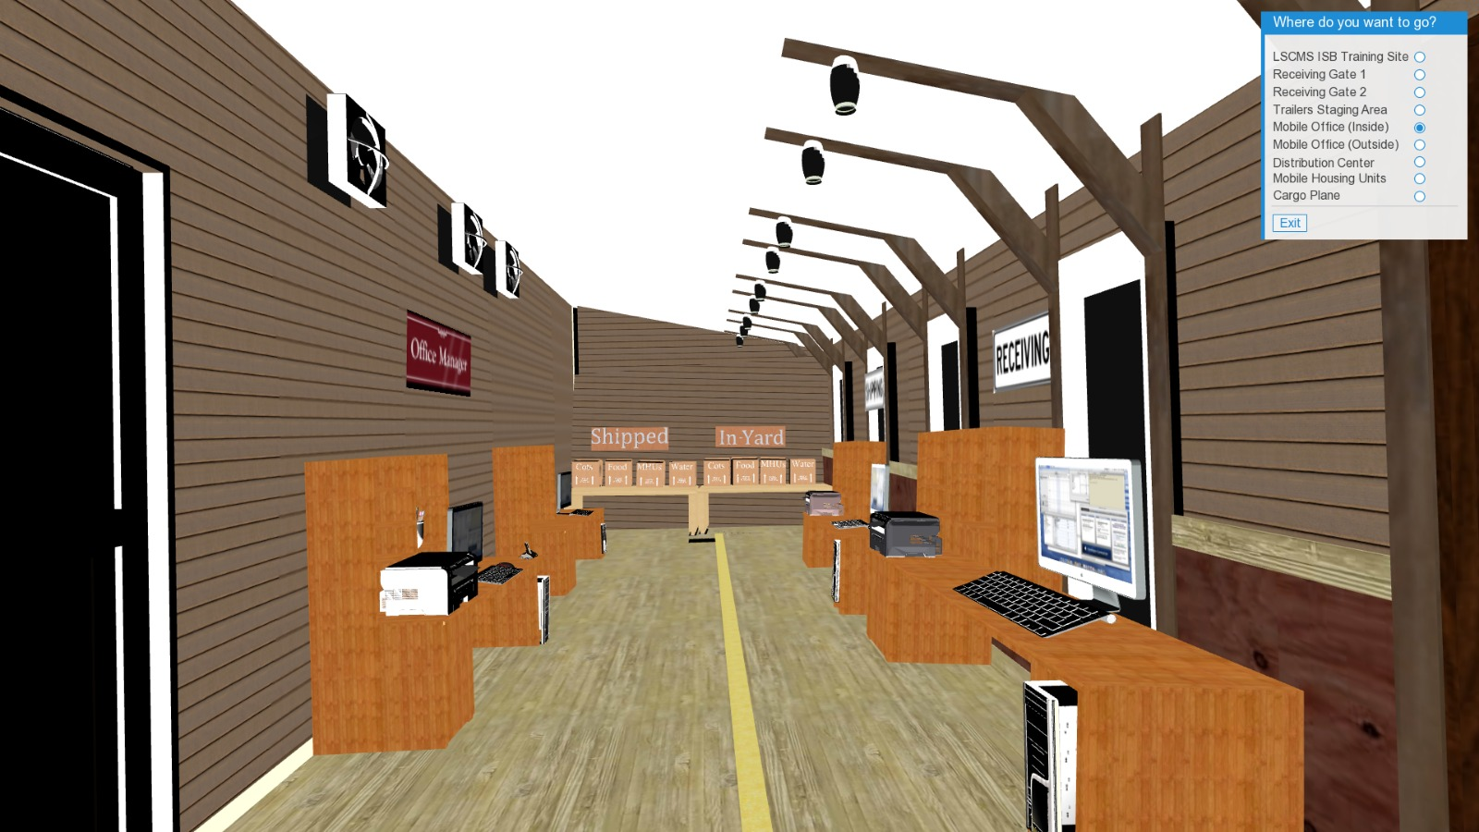

Mobile Office – inside

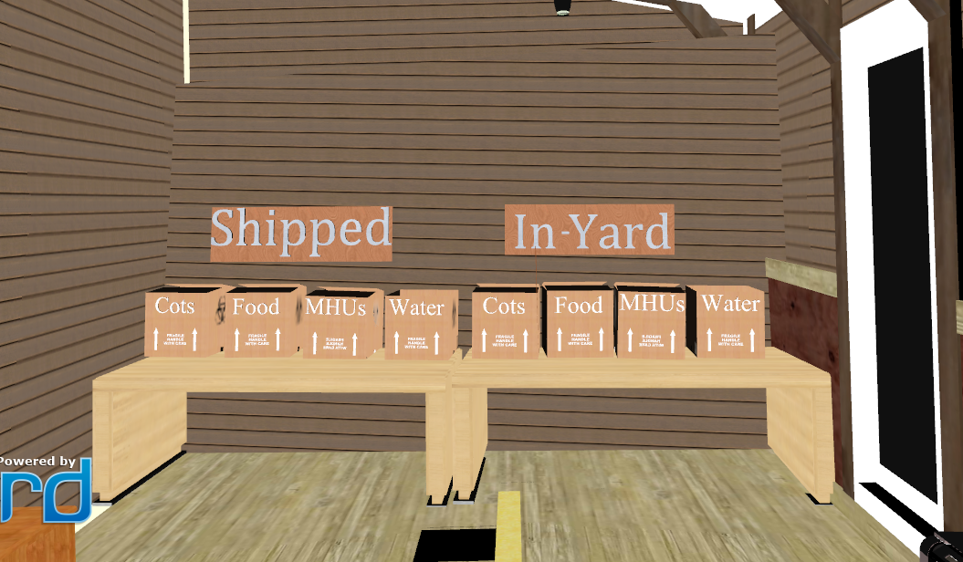

Details at the inside of the office

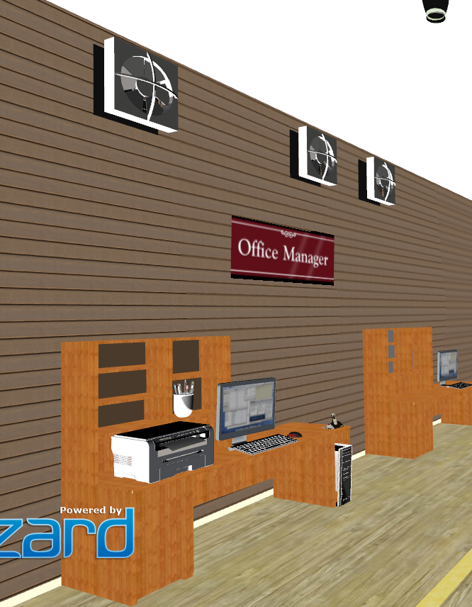

The Office Manager at the inside of the office

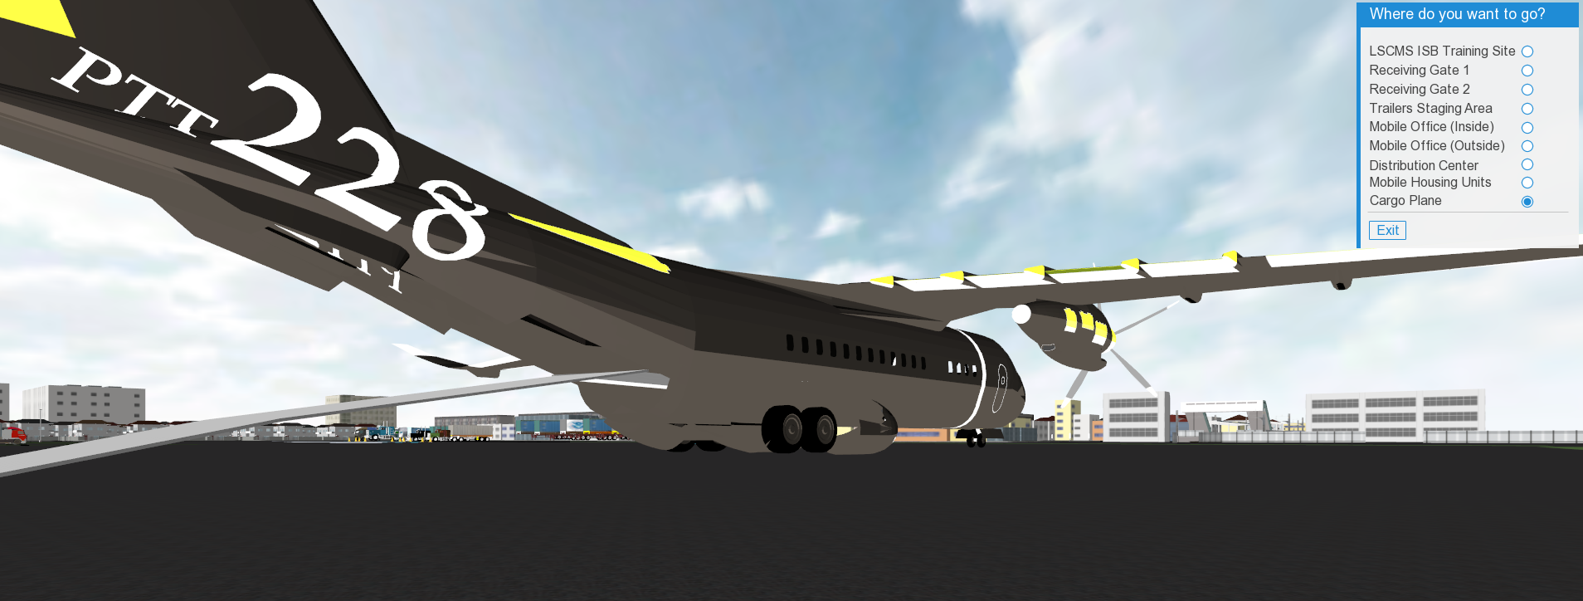

Cargo Plane

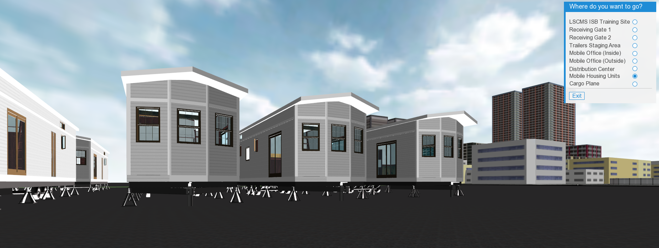

Mobile Housing Unit

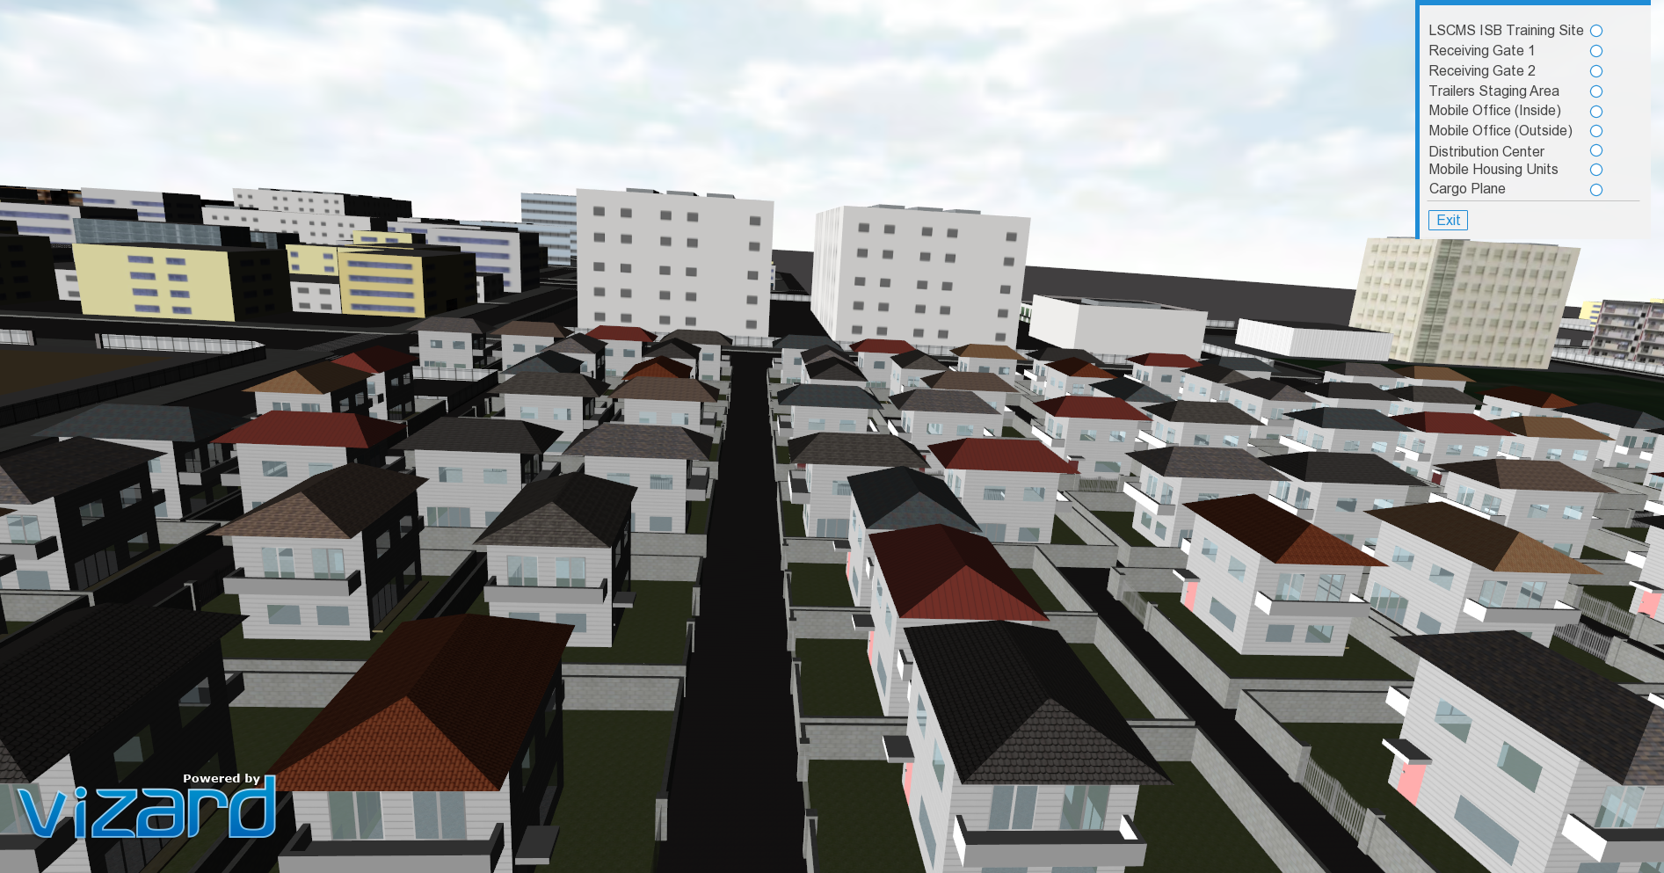

Small town near the distribution center

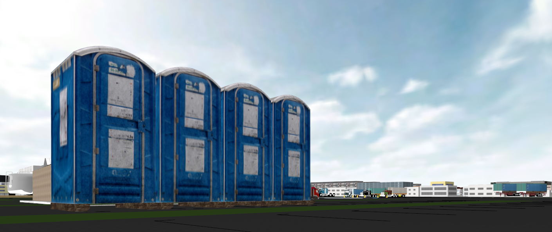

portable restrooms

**Game Theme**

As the user approaches the warehouse or chooses to be redirected to the inside of the warehouse, a proximity sensor will be triggered and an info panel will pop up asking the user if he wants to start the simulation of the emergency alert. The warehouse has equipment and avatars that walk around and others standing. Pressing that key will automatically start the alert by changing the shade color of the screen to sepia and will simulate a fire at a certain area in a nearby town. The user will have another pop up info panel that informs him to press the ‘SPACEBAR’ button if he wants to start the simulation of the tasks required to load the truck and ship it. Pressing the spacebar will start a countdown to time the user as this task has to be done in a timely manner. The user’s task inside the warehouse will be to click on a designated key pad ‘INSERT’ mentioned in the info panel for the receiving truck to park inversely simulating a beep sound when backing up triggered by proximity sensors. Then, the user will be able to see the avatars inside the warehouse being busy. If the user doesn’t complete the task within the time limit, a message will pop up that the user ran out of time and this stage will be completed.

As per the assessment training area, the user can either navigate towards the receiving gates or can click on the navigation panel to redirect him to the assessment area.

At the Receiving Gates 1 and 2, using proximity sensors a message prompt will inform the user that there are three different scenarios related to that area. When the user Clicks on the blue square on the floor, a question will pop up where the user will have to submit his answer. Once the answer is correct, an html form will appear on the screen where the user will need to fill out and will be redirected to the mobile office where the receiving forms go.

Similarly, to the Receiving Gates 1 and 2, the user will also have a proximity sensor at the trailers staging area and will have a question to answer but will not have a form to fill out.

If the user wants to navigate around the environment to discover what else the center contains, he can see the tents and mobile housing units and will also be able to go to the Cargo Plane where there is a proximity sensor that asks the user if he wants to go inside the plane and once he clicks on yes, the viewpoint automatically moves to the inside.

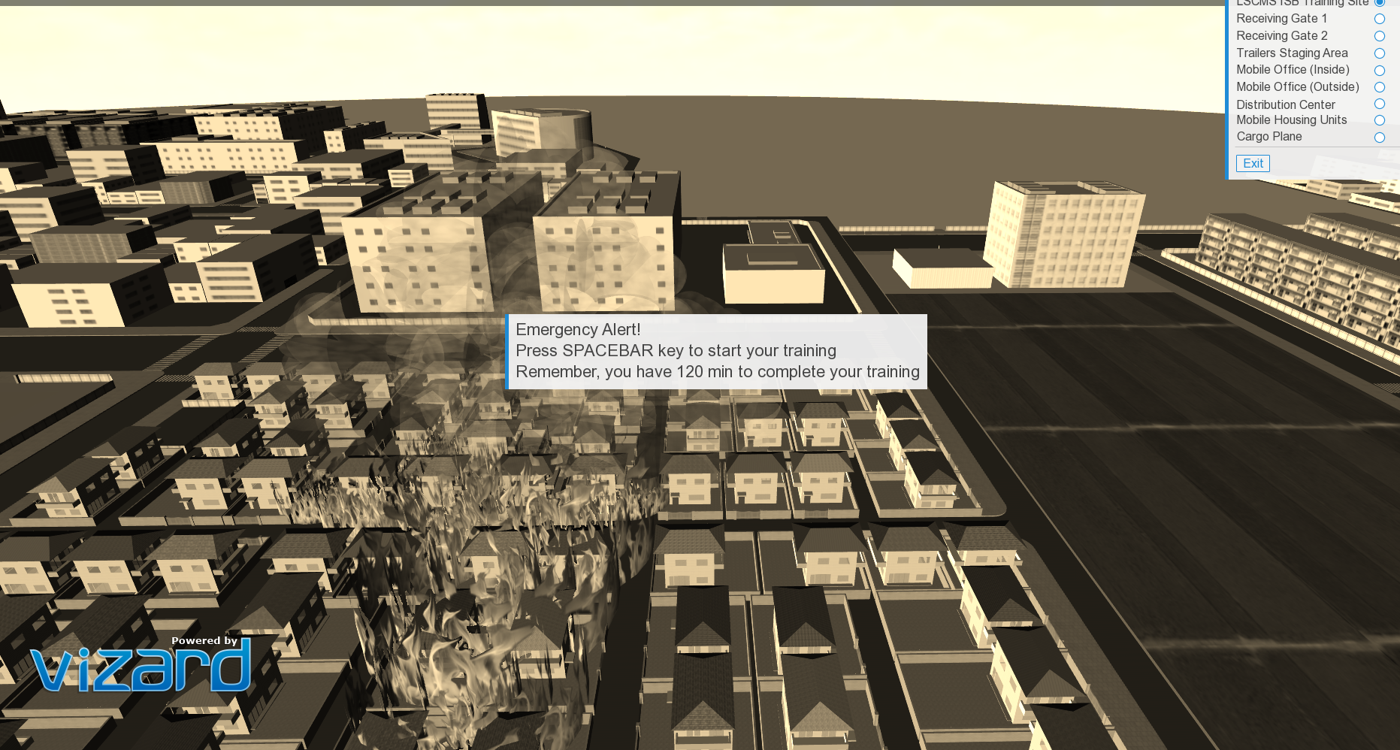

Emergency Alert- shade to the screen changes

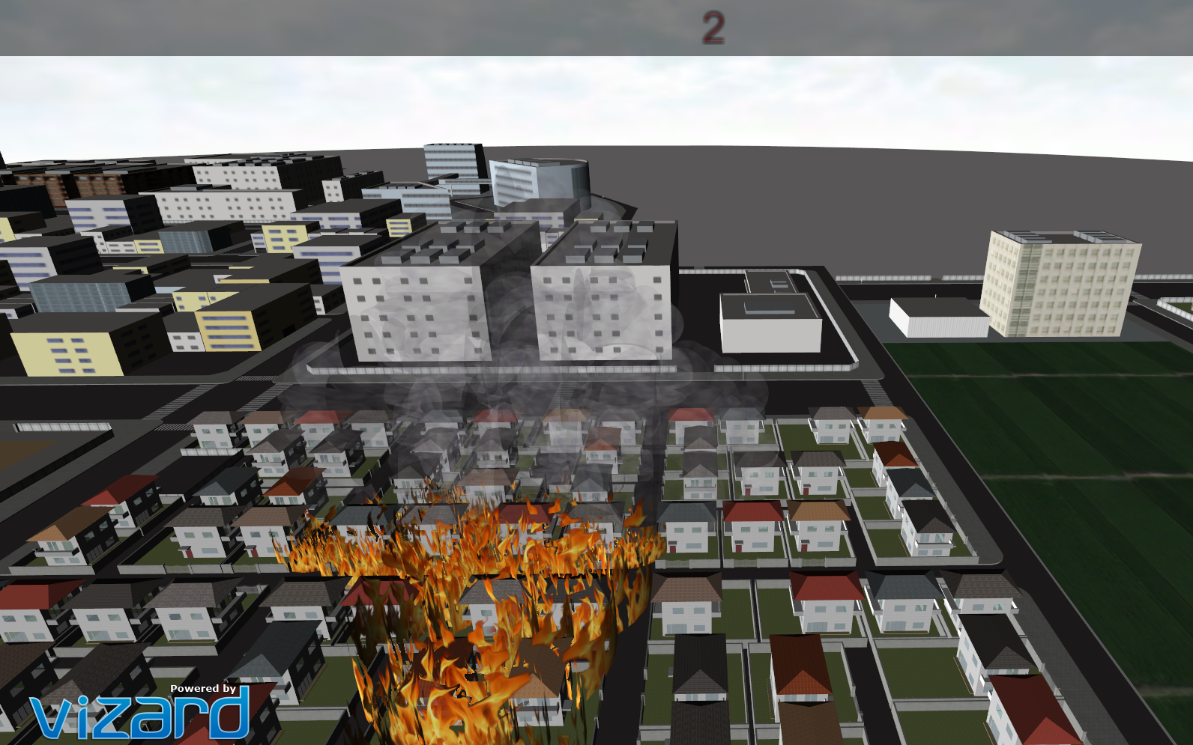

Timer when the simulation of the emergency alert starts

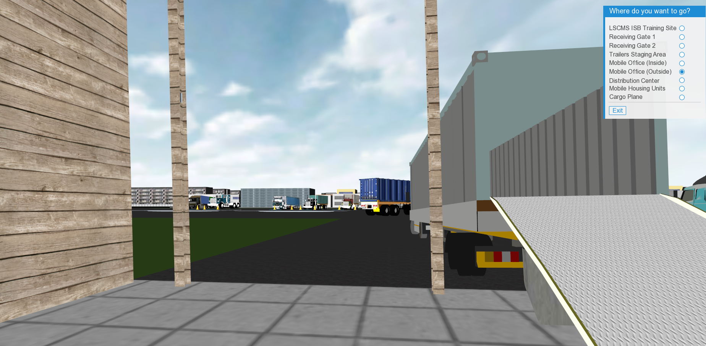

Parking Truck

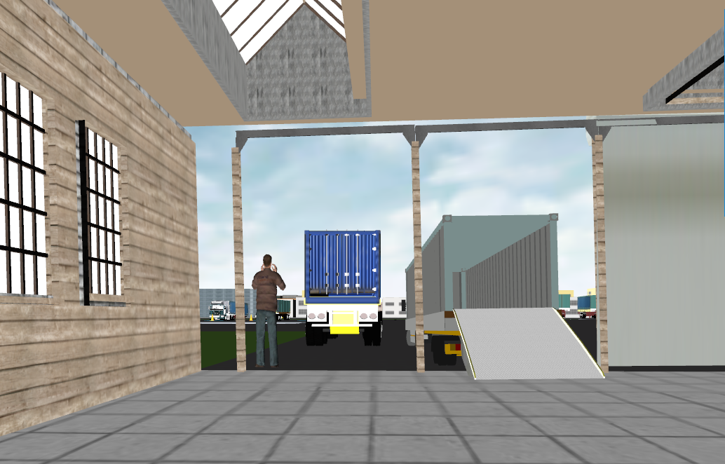

An employee directing the truck while parking

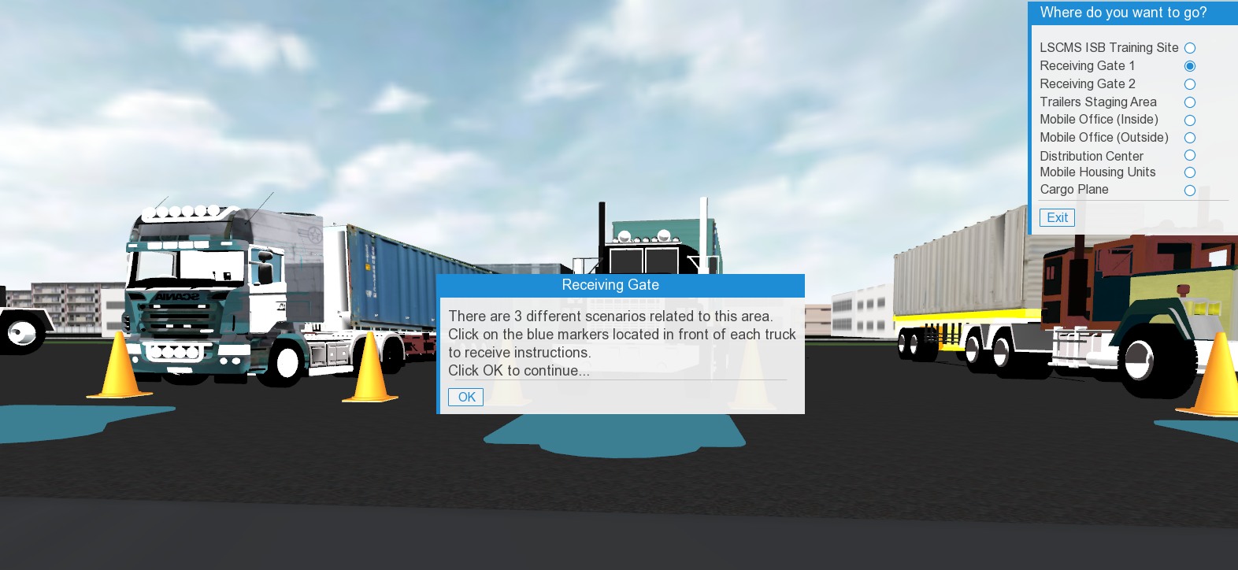

Receiving Gate 1 Training info panel

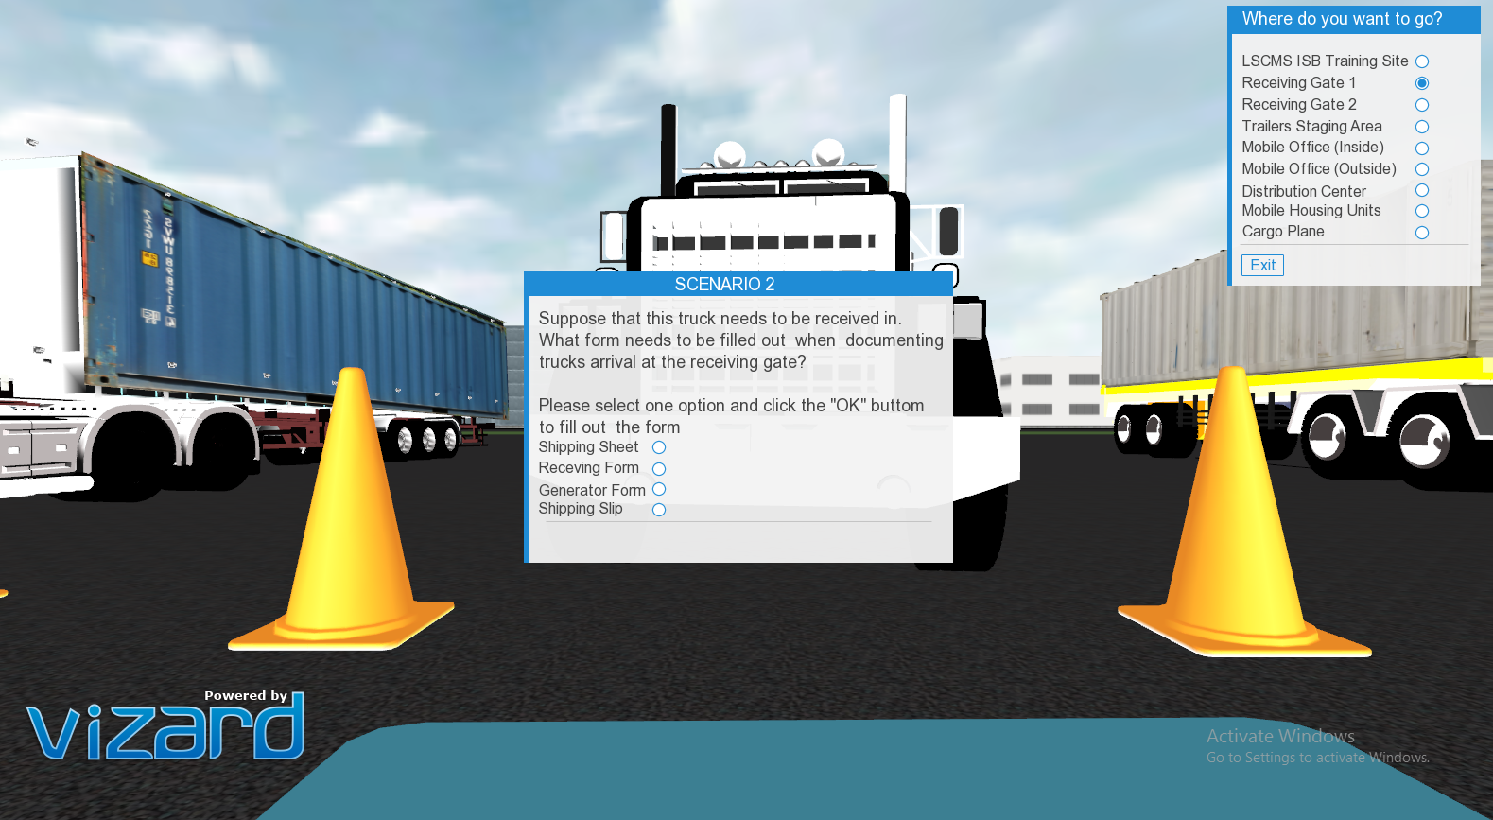

Receiving gate1 pop up question panel

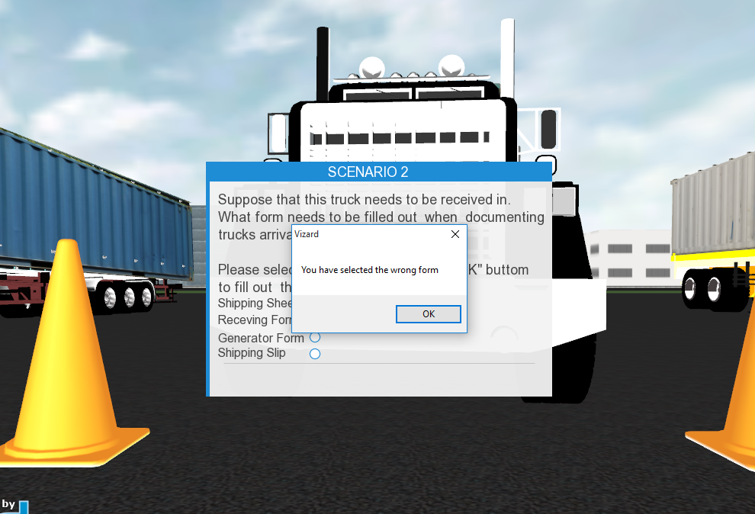

Pop up error message in case of selecting the wrong answer

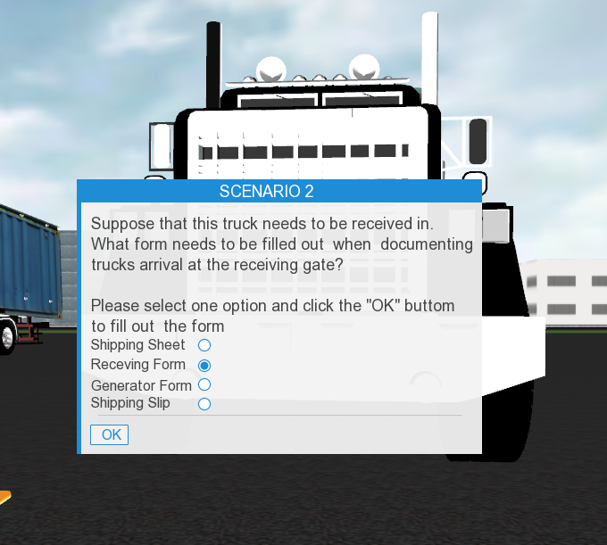

The OK button appears when the user selects the correct answer

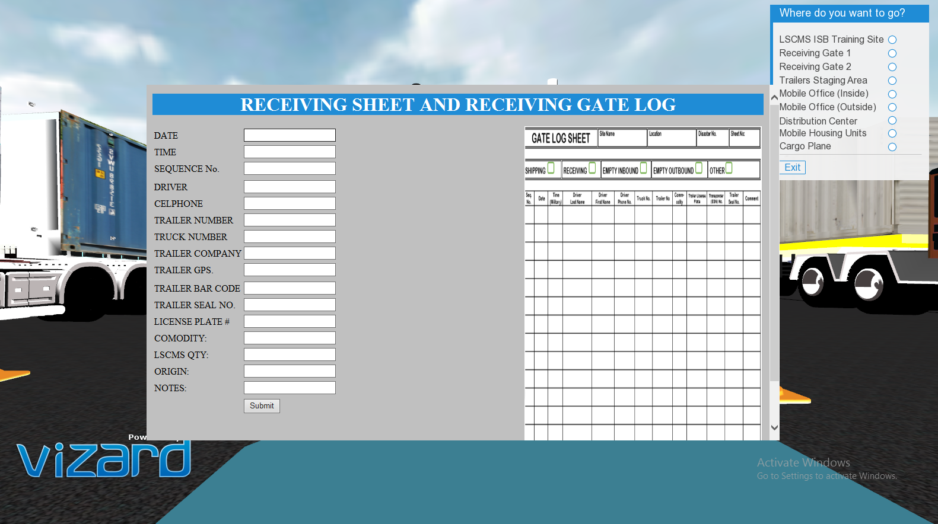

Receiving gate html form

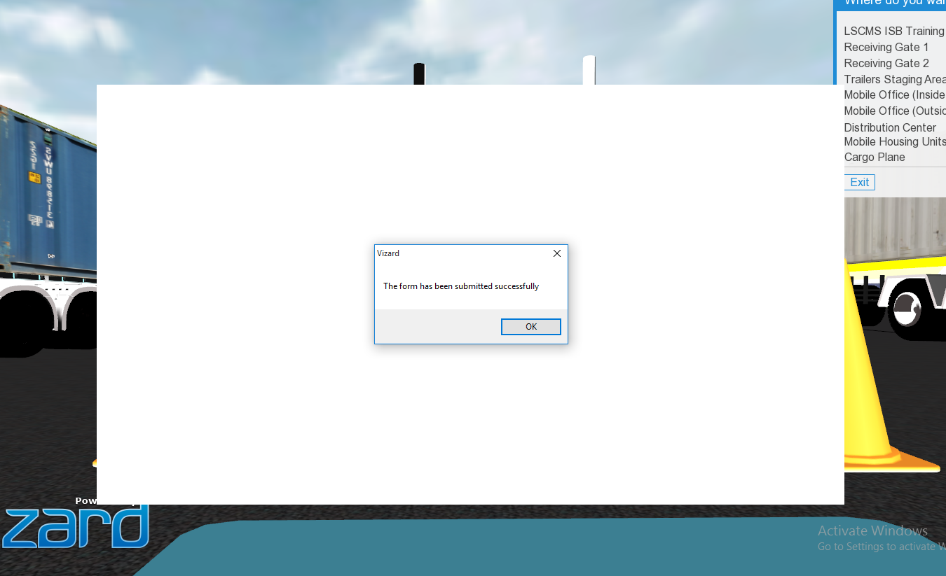

Confirmation pop up when submitting the form

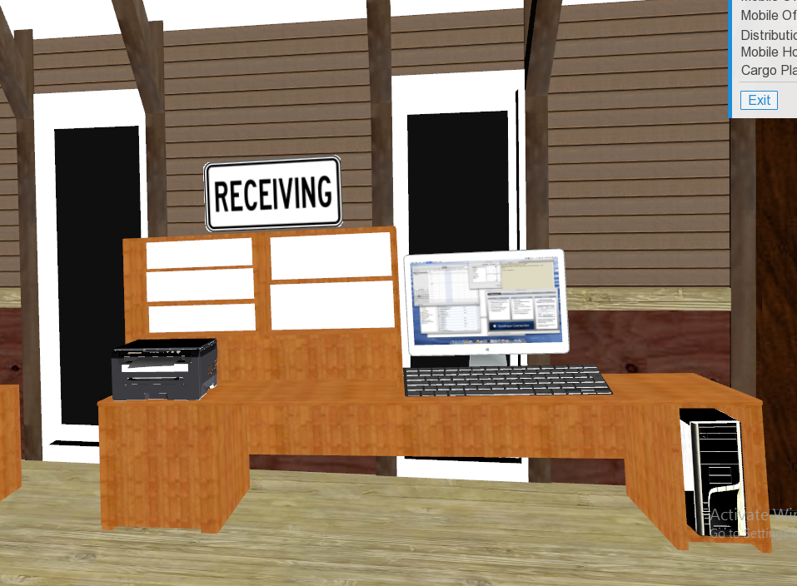

The inside of the office at the Receiving view before the submission of the form

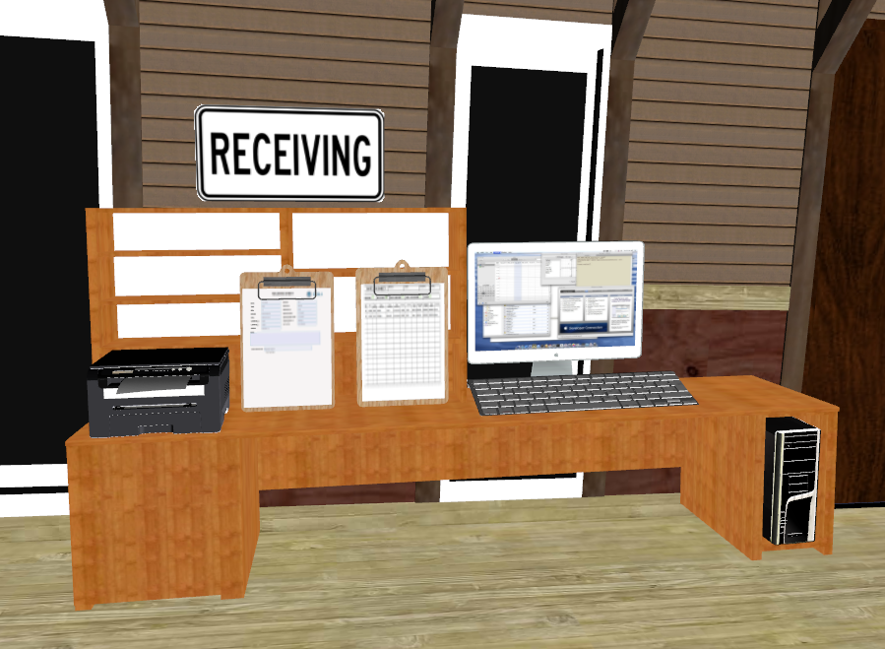

The inside of the office at the Receiving view after the submission of the form

**Vizard Functionality**

* Lights: It is very important to have the light in our project to give the environment a daytime scene. We have implemented our light in Vizard inspector and placed it closer above the warehouse. We also have two functionalities that changes the color shade of the screen. The screen color shade changes to sepia when the user decides to simulate the Emergency Alert. Also, a white flash is triggered at the timer when the user decides to start the simulation of the truck receiving, loading and shipping.
* Timers: As time is important in the Emergency Alert stage, the user will be timed using time sensors.
* Keyboard functionalities: We have implemented a good amount of keyboard functionality as the user navigates. We have proximity sensors in almost every stage in the training as well as inside the warehouse. Our proximity sensors have been used at the warehouse during the receiving of the truck. The user has to press a designated key for the truck to park inversely. While the truck is backing up, it touches a proximity sensor to start a beep sound and stops at the second sensor when the truck stops as well. We also have another sensor by the warehouse that triggers a pop up info panel that asks the if the user wants to start the simulation of the emergency alert. We have sensors when approaching the receiving gates and trailer staging areas which triggers a pop up info panel to inform the user to click on a blue spot on the floor to start the assessment. Another proximity sensor is by the cargo plane which triggers a pop up screen that asks the user if he wants to go inside the plane.
* Avatar Animation: As our avatars are not our main focus in this project, we have a few that walk around in a loop and the others that are standing to make the environment look more realistic.
* Audio file: We have implemented two audio files; one is for the beep when the receiving truck is backing up, and the other sound which is an emergency alert sound that’s triggered once the user decides to start the simulation of the Emergency Alert.

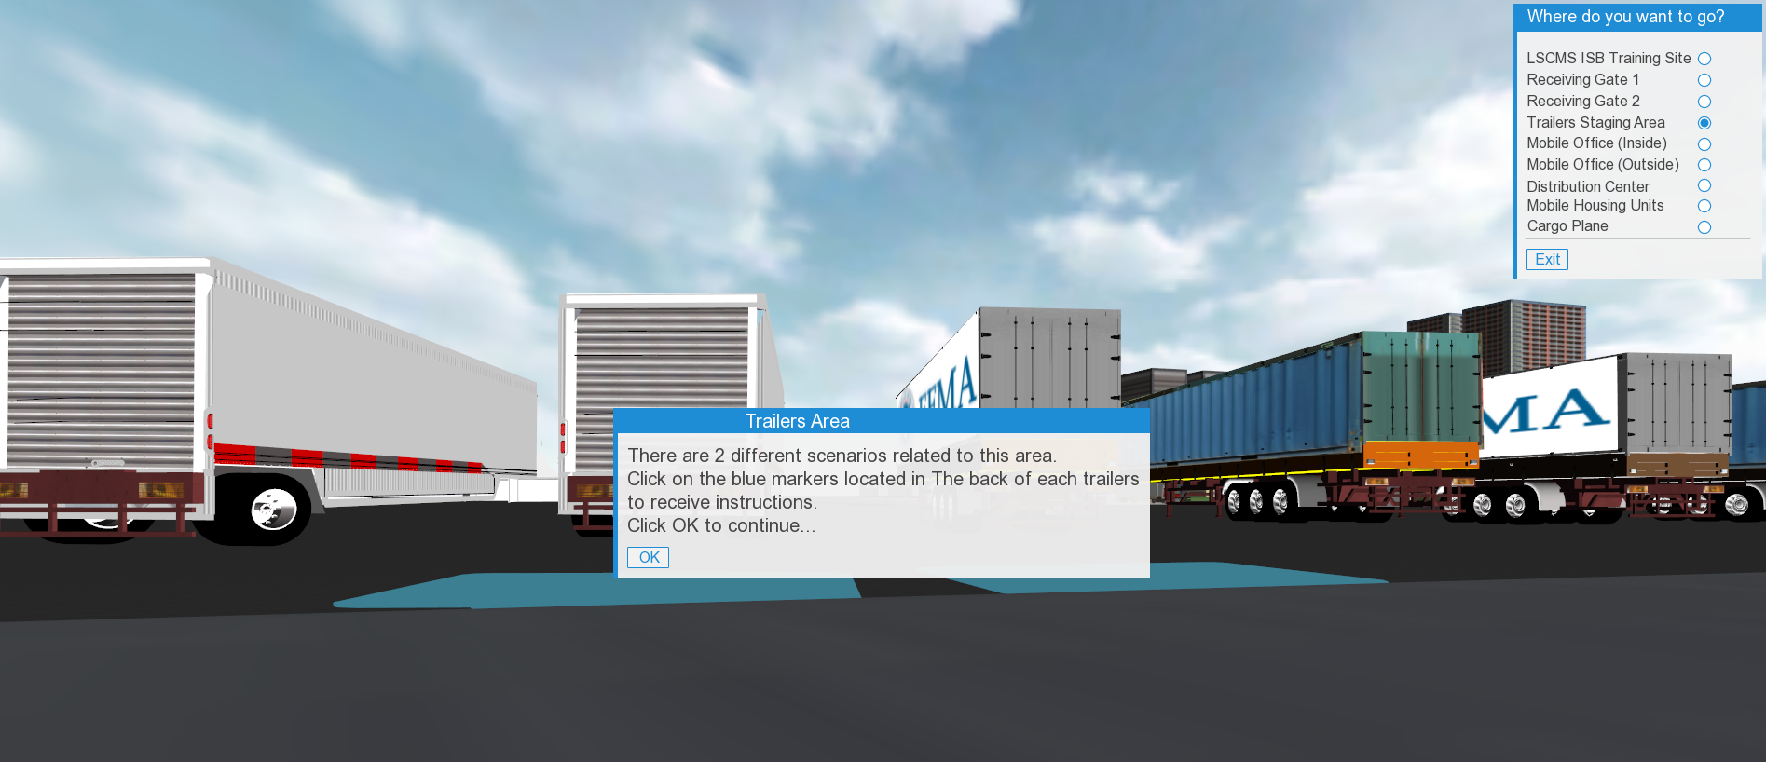

Info panel message at the back of the trailers area

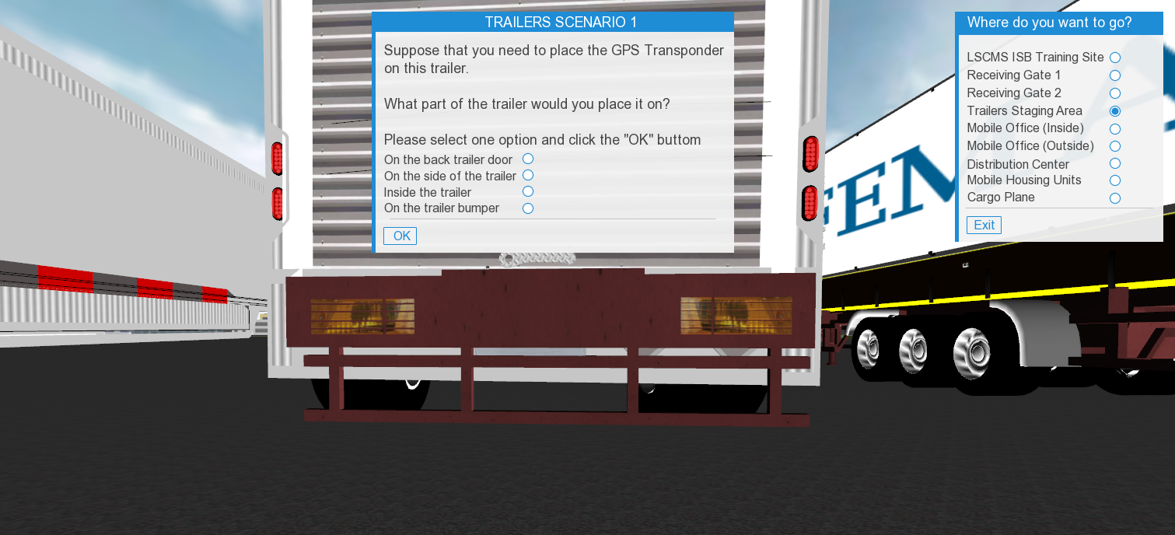

Info panel message at the back of the trailers area that tests the trainee

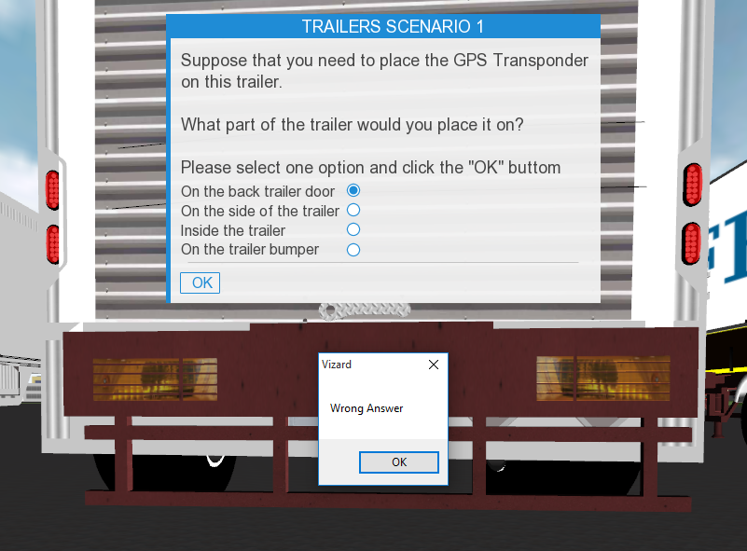

Pop up error message at the back of the trailers area when selecting the wrong answer

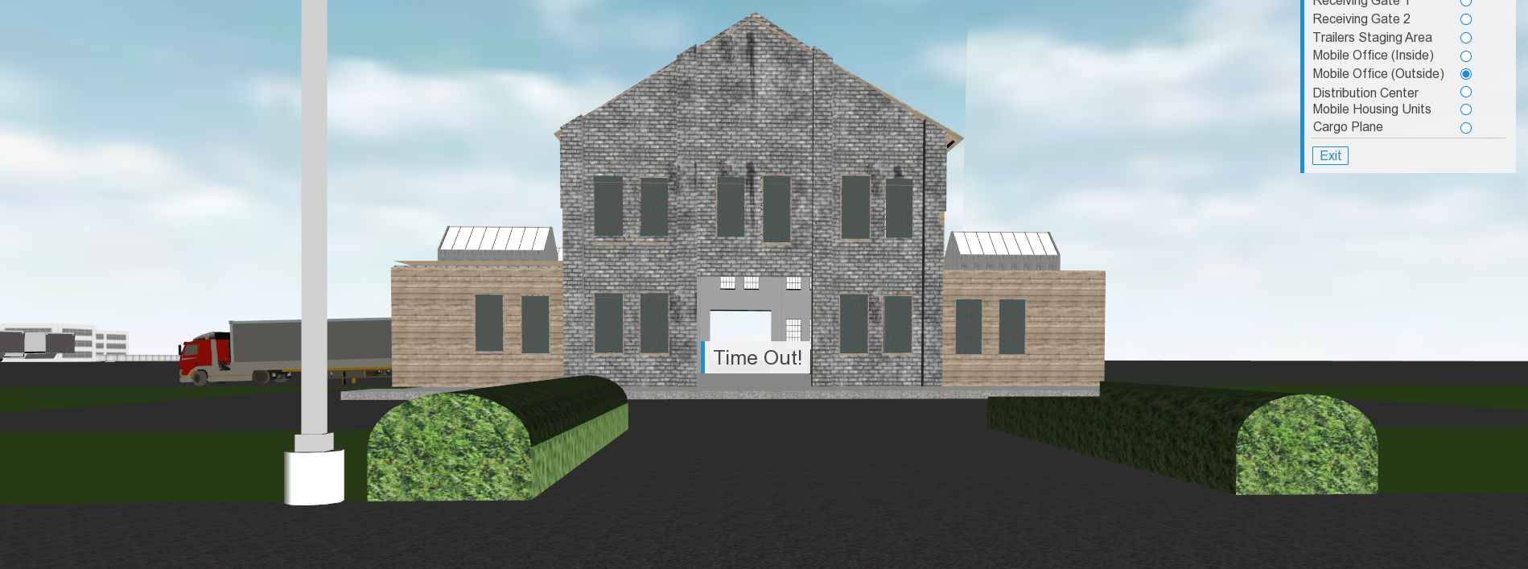

Time Out info panel message when the timer is over